Course Name | ITD 2313 – Script Programming
Instructor | Rene Hurst
Student Name | Pete Fuentez
Due date | Sep 15 by 11:59 pm
Grade | Put grade earned here
Grading Comments | Put instructor comments here

Week 2 - Scripting Projects Assignment

Pages 50-51
Project # 2
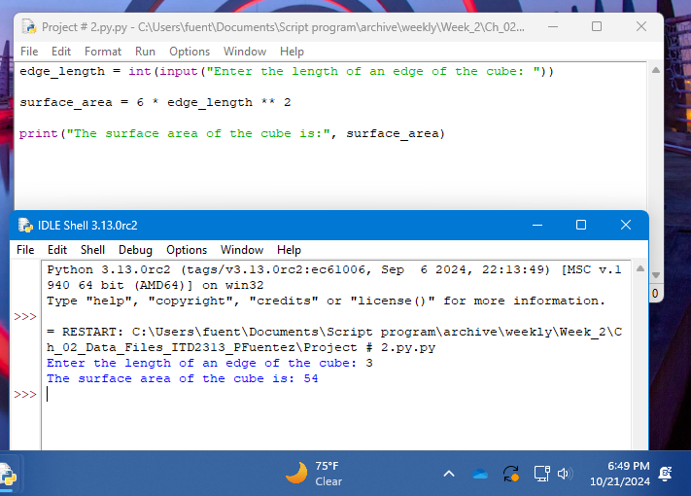

Project # 4
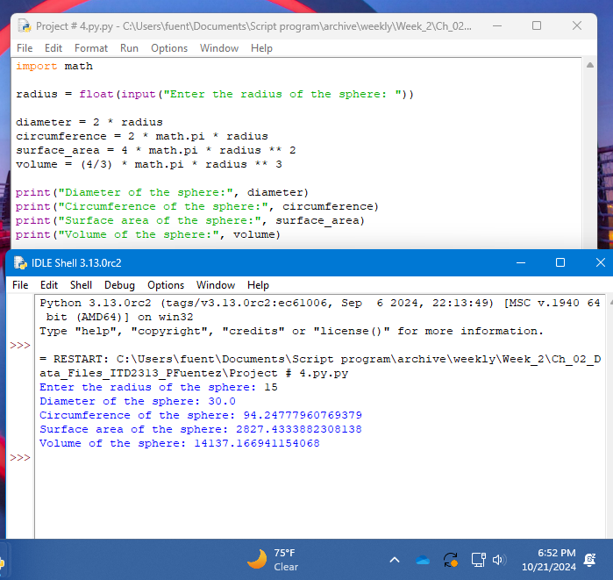

Project # 5
